Separation officer : kirti lingayat

Ph: 8976215175

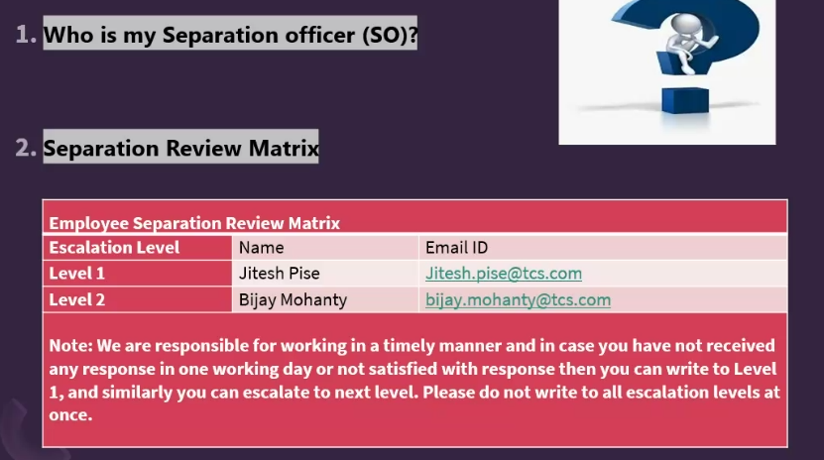

Separation checklist :

PF withdraw form – req as part of backup purpose .

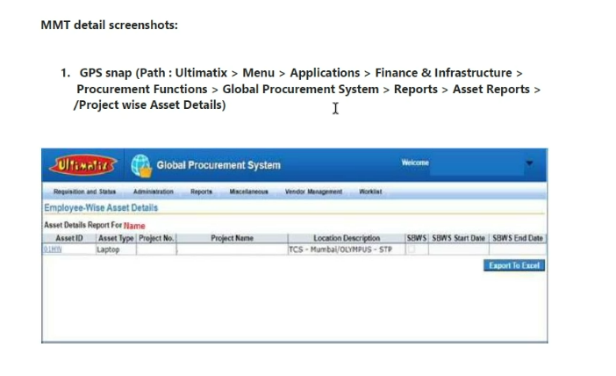

Check whether mmt is raised .

IS / admin clearance need to be done connect with spoc .

Connect with is team and ask to submit clearance to separation officer .

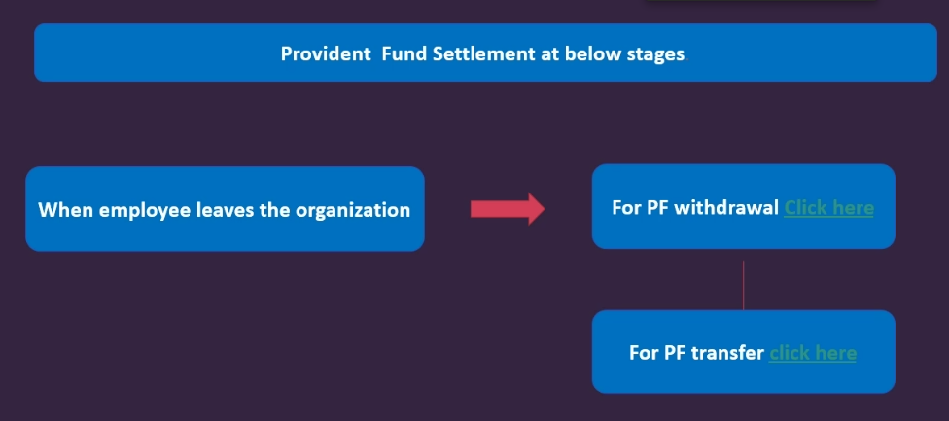

To transfer pf refer online pf transfer process . – after 60 days of np .

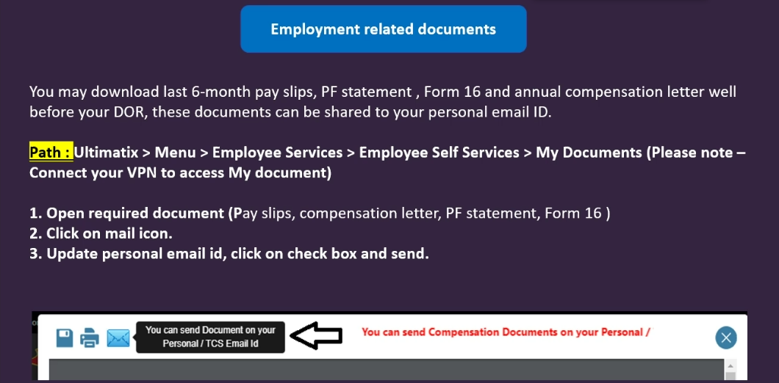

Register to alumni after 2 days to release .

Experience letter / relieve letter after 45 days in alumni .

Initial release letter on personal mail .

Admin clearance – id card .